**Designing The ViewScoresFrame**

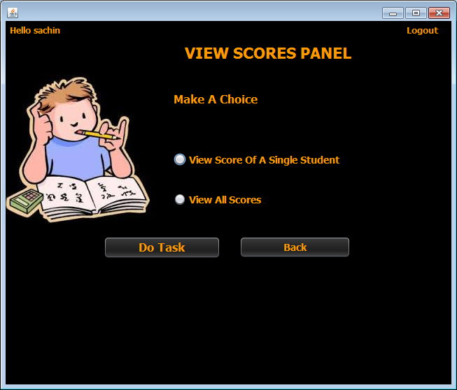

**STEPS TO BE DONE IN** **ViewScoresFrame**

In the **ViewScoresFrame** we need to do following steps:

1. Display **username** on the top left

2. Allow the user to **logout**

3. Write code for the "**Do Task**" Button . When this button is clicked it should:

**a. Validate the inputs. If validation fails it should print the Error Message and return**

**b. If Single Student Score is selected it should open the ViewSingleScoreFrame and if all scores is selected it should open the AllScoresFrame**

**c. Dispose the current frame**

4. Write code for the "**Back**" Button . When this button is clicked it should:

a**. Dispose the current frame and open the AdminOptionsFrame**

**DESIGNING THE validateInputs( ) METHOD:**

***private boolean validateInputs(){***

***if(jrSingleScore.isSelected()==false && jrAllScores.isSelected()==false)***

***return false;***

***else***

***return true;***

***}***

**WRITING THE CODE FOR BUTTON Button.png IN ViewScoreFrame**

***private void btnTaskActionPerformed(java.awt.event.ActionEvent evt) {***

***if(validateInputs()==false){***

***JOptionPane.showMessageDialog(null, "Please Choose An Option","Error!",JOptionPane.ERROR_MESSAGE);***

***return;***

***}***

***if(jrSingleScore.isSelected())***

***{***

***ViewSingleScoreFrame singleScoreFrame=new ViewSingleScoreFrame();***

***singleScoreFrame.setVisible(true);***

***}***

***else***

***{***

***ViewAllScoresFrame allScoreFrame=new ViewAllScoresFrame();***

***allScoreFrame.setVisible(true);***

***}***

***this.dispose();***

***}***

**WRITING THE CODE FOR BUTTON Button.png IN EditQuestionsFrame**

***private void btnBackActionPerformed(java.awt.event.ActionEvent evt) {***

***AdminOptionsFrame adminFrame=new AdminOptionsFrame();***

***adminFrame.setVisible(true);***

***this.dispose();***

***}***